

PDR

AI for Society



Tony Jiang

Table of Contents

Introduction 3

Individual Project 3

Group Project 3

Learning Outcome 1 Societal Impact 3

First Evaluation: week 4 4

Self-assessment 4

Feedback Evidence 4

Second Evaluation: week 8 5

Self-assessment 5

Feedback Evidence 6

Learning Outcome 2 investigative Problem Solving 6

First Evaluation: week 4 6

Self-assessment 6

Feedback Evidence 7

Second Evaluation: week 8 7

Self-assessment 7

Feedback Evidence 7

Learning Outcome 3 Data Preparation 8

First Evaluation: week 4 8

Self-assessment 8

Feedback Evidence 9

Second Evaluation: week 8 9

Self-assessment 9

Feedback Evidence 10

Learning Outcome 4 Machine Teaching 12

First Evaluation: week 4 12

Self-assessment 12

Feedback Evidence 12

Second Evaluation: week 8 12

Self-assessment 12

Feedback Evidence 12

Learning Outcome 5 Data Visualisation 12

First Evaluation: week 4 13

Self-assessment 13

Feedback Evidence 13

Second Evaluation: week 8 13

Self-assessment 13

Feedback Evidence 13

Learning Outcome 6 Reporting 13

First Evaluation: week 4 13

Self-assessment 13

Feedback Evidence 14

Second Evaluation: week 8 14

Self-assessment 14

Feedback Evidence 14

Learning Outcome 7 Personal Leadership 15

First Evaluation: week 4 15

Self-assessment 15

Feedback Evidence 15

Second Evaluation: week 8 18

Self-assessment 18

Feedback Evidence 18

Learning Outcome 8 Personal Goal 18

First Evaluation: week 4 18

Self-assessment 18

Feedback Evidence 18

Second Evaluation: week 8 18

Self-assessment 18

Feedback Evidence 19

Retrospective 19

Conclusion 19

# Introduction

This is my Personal Development Report (PDR). My name is Tony, and I am from Aruba. I came to the Netherlands to study ICT software engineering. In my downtime, I like to go hiking or exploring different places in the Netherlands.

The reason I choose this minor is to learn how AI is developed like what type of data is it getting, how would it use the data, etc. This will give me insight into how AI models work, as I currently use AI primarily as a search engine or for explanations on software methodologies and best practices.

## Individual Project

For my individual project, I want to create a top-hit song prediction AI that new artists can use to improve their songs and increase their chances of making a hit. For example, the AI could provide feedback on whether the energy of their song should be higher or lower to enhance its hit potential.

## Group Project

For our group project, we have been tasked with creating an AI tutor for secondary schools in the Netherlands. The AI tutor will serve as an assistant to teachers, allowing them to manage all learning materials within the system. Students can use the AI tutor to ask questions about the materials when they need further clarification.

Additionally, the AI tutor will provide exercises tailored to each student's learning level and monitor their progress. If a student is struggling, the AI tutor will notify the teacher so they can provide additional support.

# Learning Outcome 1 Societal Impact

This learning outcome focuses on considering the impact of your AI project on society in different perspective. Think about how your AI project will affect society and take data regulations regarding users into account.

## First Evaluation: week 4

### Self-assessment

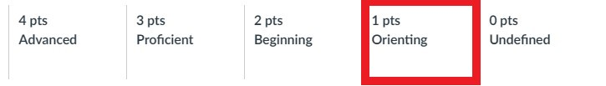

I assess myself as orienting because I have started to consider the societal impact of my individual project, including both its positive and negative effects. The positive impact of my project is helping new artists improve their songs to become top hits. However, there are also potential negative impacts, which I have outlined in my Personal Challenge Proposal document.

I also talked to one of the teachers about the societal impact that I thought about. Some positive and negative impact it could have.

For the group we haven’t think about it yet.

### Feedback Evidence

Here is the part of the societal impact, that I wrote about in my Personal Challenge Proposal document.

Here is the FeedPulse feedback that I talked to Jacco about my societal impact.

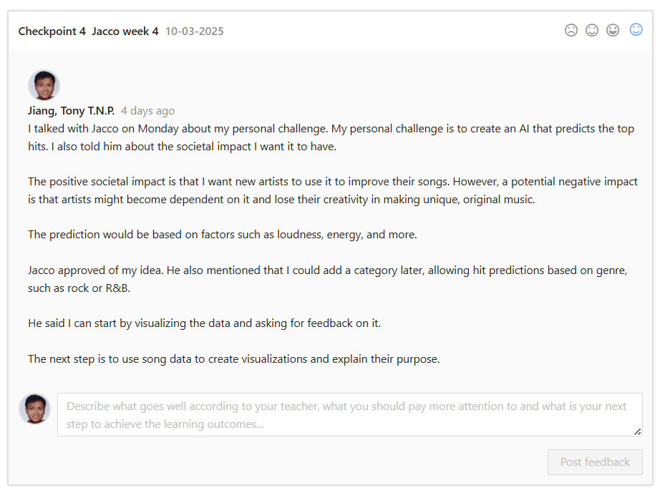

## Second Evaluation: week 8

### Self-assessment

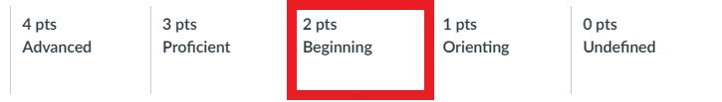

I assess myself as a beginner because I have created a societal impact document in which I considered different perspectives on my individual project, such as its potential impact on society, including privacy, data usage, target users, transparency, hateful and criminal actors and other consideration that has to do with societal impact. Additionally, I received feedback from Danny that the document was good, and I plan to review it again at the end of the semester to see if my views have changed since I first wrote it.

### Feedback Evidence

Here is the societal impact document that I have written for my individual project and below that I the feedback I got from Danny on my societal impact document that I need to revisit later on.

[Societal Impact Document](https://stichtingfontys-my.sharepoint.com/personal/457292_student_fontys_nl/Documents/Societal%20Impact%20Document.docx?web=1)

# Learning Outcome 2 investigative Problem Solving

This learning outcome focuses on you to be able to identify problems within your AI project and develop solutions to address them.

## First Evaluation: week 4

### Self-assessment

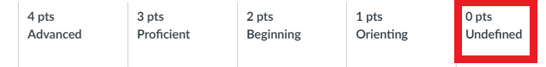

I asses myself as undefined. I have yet to identify problems in my individual project and group project.

### Feedback Evidence

No evidence.

Second Evaluation: week 8

Self-assessment



I assess myself as a beginner because, for my individual project, I created a societal impact document where I reflected on potential problems that could arise. For example, if I were to sell my project, an AI model that predicts top hit songs, to a company, it might be used in a way that changes its original purpose. I also proposed a solution to address that issue.

For my group project, we researched a problem by formulating it as a question, write down the methodology we are going to use from the DOT framework, investigating it, documenting our findings, testing possible solutions, and drawing a conclusion. One example of a problem we explored was: “How can an OpenAI assistant be implemented for the AI Tutor?”

Feedback Evidence

Here is the evidence about the problem I thought about if I sold my individual project and the solution I came up with. It from my societal impact document in the “Future” section.

[Societal Impact Document](https://stichtingfontys-my.sharepoint.com/personal/457292_student_fontys_nl/Documents/Societal%20Impact%20Document.docx?web=1)

Here are the research documents we have done for the group.

# Learning Outcome 3 Data Preparation

This learning outcome focuses on collecting data, estimating its volume, and using it appropriately in your AI project.

## First Evaluation: week 4

### Self-assessment



I assess myself as orienting because I have explored the data I need for my individual project. Specifically, I analyzed song data for hit song prediction. I examined the attributes that could be useful for prediction, such as the song’s energy, loudness, and other relevant features, instead of using the song's MP3 file.

Additionally, I received feedback from Jacco, who said it’s a good idea.

### Feedback Evidence

Here is the FeedPulse that I had feedback from Jacco after discussing the song data with him, including the attributes I can use for my hit song prediction.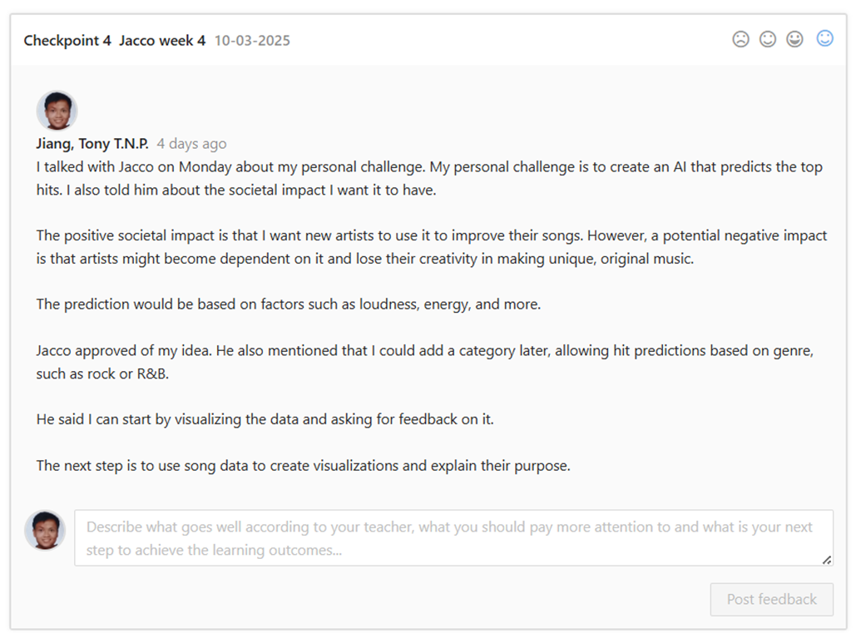

Second Evaluation: week 8

### Self-assessment



I assess myself as a beginner because, in the societal impact document, I reflected on data accuracy, the type of data being collected, and how that data is being used. I also cleaned my dataset by removing unnecessary columns and empty entries to ensure they wouldn't interfere with the model training and testing process.

For the group project, we are using exam assignments from examenblad.nl to test the OpenAI assistant, which we are using to build an AI tutor. Since the OpenAI assistant is already pre-trained, we don’t need to train it ourselves instead, we focus on instructing the model on how to work with our specific data. The data that is being uploaded is a PDF, but it can be other file type like

### Feedback Evidence

Here is the evidence that I thought about the data in my societal impact document.

Here is where I clean my data for my individual project.

Here is the mention on what you can upload for the OpenAI assistant and give it instructions for the group project. Also below is the from the research we did on OpenAI Assistant.

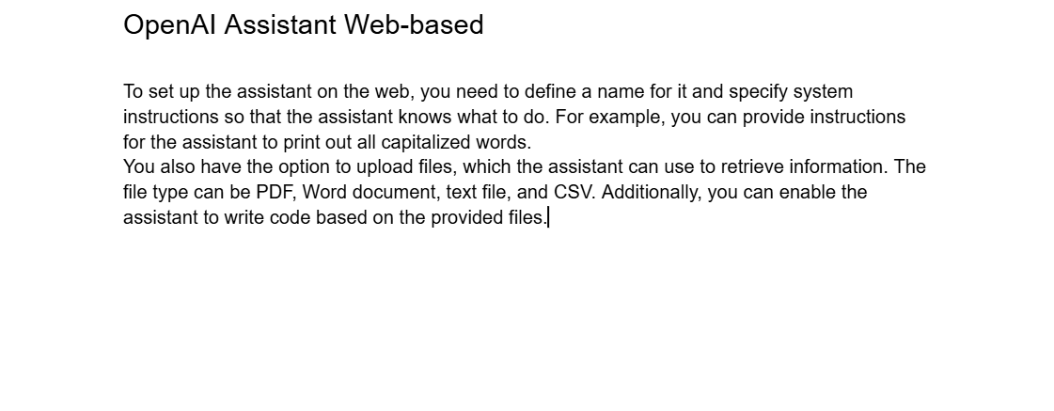

# Learning Outcome 4 Machine Teaching

This learning outcome focuses on training an AI model with the provided data to ensure it serves its intended use. Additionally, it involves testing the model to verify that it has been trained correctly

## First Evaluation: week 4

### Self-assessment



I assess myself as undefined because I haven’t looked into training an AI model for my individual project and group project yet.

### Feedback Evidence

No evidence.

Second Evaluation: week 8

Self-assessment



I assess myself as orienting because, in our group project, we created a prototype of the AI Tutor using the OpenAI Assistant API. We upload exam documents to test the data and test how it works. We gave the model specific instructions on how to use the data and how to respond, in order to better understand how the OpenAI Assistant works and how we could implement it for the AI Tutor.

Feedback Evidence

Here is the research document we created on the OpenAI Assistant, explaining how we tested it and evaluated how it works.

# Learning Outcome 5 Data Visualisation

This learning outcome focuses presenting data in a meaningful and educational way about the data, allowing the target users to interact with and understand the information that is being displayed.

## First Evaluation: week 4

### Self-assessment



I assess myself as undefined because I have not yet started visualizing my data in a meaningful way for either my individual or group project.

### Feedback Evidence

No evidence.

Second Evaluation: week 8

Self-assessment

Feedback Evidence

# Learning Outcome 6 Reporting

This learning outcome focuses on creating a report about your AI project or group project in a best-practice manner. The reporting can be from project proposal, process documentation, etc.

## First Evaluation: week 4

### Self-assessment



I assess myself as orienting because I for my individual, I have created a Personal Challenge Proposal outlining what I want to do for my individual project. I also asked Jacco for feedback to ensure my idea is feasible.

For the group project, we created a Group Project Proposal, which is currently in draft form. We have already asked Danny for feedback on areas for improvement. Currently, the proposal is under review by the client.

### Feedback Evidence

Here is the FeedPulse where I have talked to Jacco about my Personal Challenge Proposal.

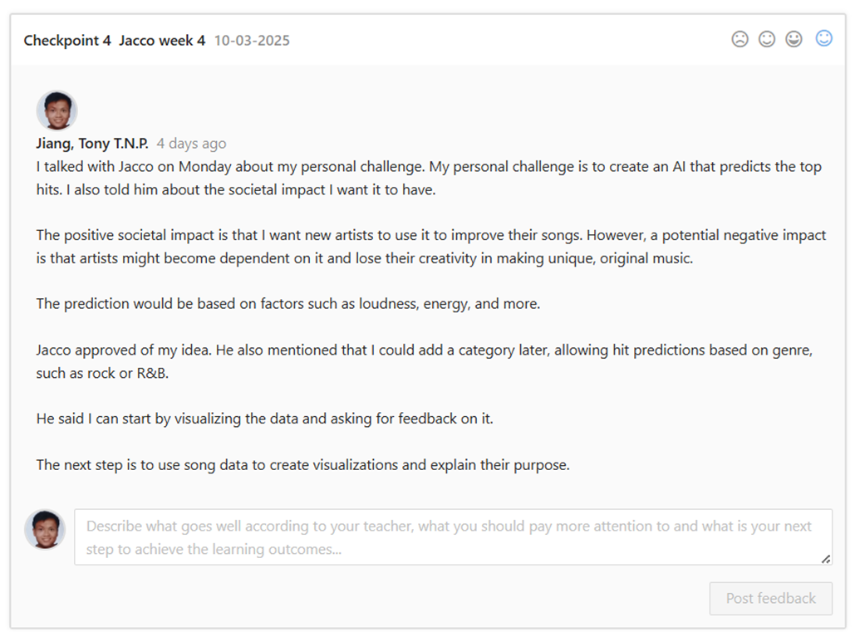

Second Evaluation: week 8

Self-assessment

Feedback Evidence

# Learning Outcome 7 Personal Leadership

This learning outcome is about innovating, problem-solving, adaptability and taking initiative in your personal AI project, the group project and personal development. Additionally, it emphasizes on being aware of how much you can learn and keeping your professional goal in mind for your future work field.

## First Evaluation: week 4

### Self-assessment



I assess myself orienting because I have taken the initiative in my individual project by seeking feedback and consulting teachers on how to begin and what to consider. I asked for guidance on where to find data online and whether my project idea was feasible. Initially, I was unsure where to start, but after discussing my ideas, reflecting, and receiving feedback from the teachers, I was able to define a project that I wanted to create.

Before joining a group project, my groupmate Le Thi Thuy (Sally) and I worked together to come up with an idea for the ideation project. We discussed the project's problem, goal, advantages, disadvantages, and other relevant aspects. After the discussion we created an ideation document for the idea we had discussed.

For the group project, we have thought about our priorities, what tasks to complete first, and the time constraints we must consider before the end of the semester. We have outlined our plans for this semester in the Group Project Proposal. We had feedback from Danny on what to improve on the Group Project Proposal and currently it’s in review with the client.

### Feedback Evidence

Here is some feedback from FeedPulse that I had discussed with the teachers about the individual project.

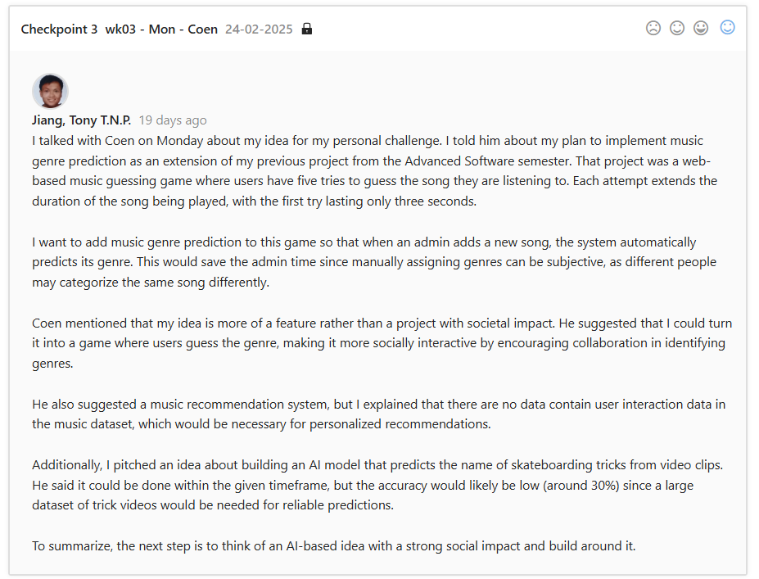

Here is a snippet of the ideation document that we created.

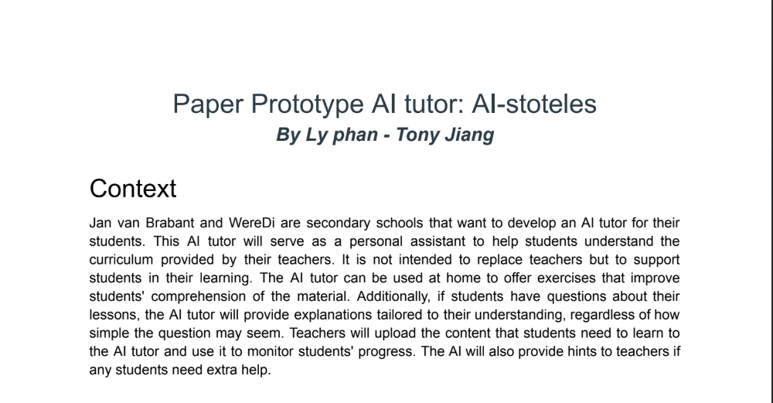

Second Evaluation: week 8

Self-assessment

Feedback Evidence

# Learning Outcome 8 Personal Goal

This learning outcome is about defining your own goals for your future field of work. It serves as your personal challenge for growth and development.

## First Evaluation: week 4

### Self-assessment



I assess myself as orienting because I have defined my personal goal in my Personal Challenge Proposal. I have reflected on what I want to learn from AI for Society and how I can apply it to my future work.

### Feedback Evidence

Here is the part where I define my personal goal in my Personal Challenge Proposal.

Second Evaluation: week 8

Self-assessment

Feedback Evidence

# Retrospective

*Fill in for the final version.*

# Conclusion

*Fill in for the final version.*